Project Analysis

Case description

Student Housing BV owns different buildings where students can stay during their study period. However, the company has recently been receiving complaints that are related to the everyday life in these student houses. The company wants to create an application which would be used to fix all of those problems. The software application should be written in C# and should be created in Visual Studio.

Problem Statement

There are a lot of different problems in the student houses which need to be fixed. For example, some of the appointed people don’t clean the shared facilities, don’t do the garbage disposal on time and the groceries are not done or paid for. Aside from that, there have also been complaints about unannounced parties and gatherings which disturb some of the students. We would also want a feature where the tenants can see and make arrangements between each other and another feature to edit the rules and to make sure that the students can see them.

Stakeholders

The people who will make the application are Viktor Skachkov, Alexander Petrov, Desislav Hristov and Matija Mandarelo. The clients who have ordered it are Student House BV and the end users who will utilize it are the students themselves and the admins who will regulate the everyday life.

Requirements

- The application should contain a login feature which prevents strangers who don’t live in the student houses from creating their own accounts. Also, there is a prevention of the students who don’t belong to the housing company by making every account pending and after that only the admin can approve accounts. The application should also recognize if the user is a student or an admin.

- Also, the students should be separated in different house addresses because the company manages more than one property. When we have this feature we can track more easily each house on a local level.

-Every admin will have a separate tab only for complaints which will be on queue. When the admin selects a complaint he will be able to check that specific house and contact all the students if needed. On the other side each student will be able to send complaints to the admins from the application anonymously.

-The task distribution is an important part of our project. The students should have schedule of doing the tasks such as:

-Garbage disposal/daily

Cleaning shared facilities:

-cleaning the left dishes/daily

-cleaning the bathroom/weekly

-cleaning the whole property/weekly

-swiping the whole property/daily.

They are separated as daily or weekly because not every task should be done every day, but weekly. The application will separate the tasks for each student, so it will be fair.

-Each data will be stored in SQL database, so we won’t lose the input data when we close the application. *//bonus feature*

-Buying of shared items. Overall when a student buys something shared, he can just input it into the application the name, the price and the quantity of the item and then the application will split the amount of money which every student should pay.

-Events/announcements. Here all the students can announce events or something else to their roommates.

Solution

We created one main class which contains lists of the other classes for convenience. We also created 4 forms - LogIn, StudentForm, AdminForm and SignIn. The app starts at the LogIn and the user needs to fill in his/her credentials and the app sends them to the student or admin form accordingly. The user can also create a new account from the SignIn form but they would need to wait for approval from the admin. The rules are created, deleted and edited by the admin and the students can see them as soon as they log in. The tasks are regularly updated by a timer and both the students and the admin can see them. The students can send complaints but the admin can’t see the identity of the sender but he can still answer them. The admin can also send messages to a specific student or to an entire building and the students can only send messages to their own building. The admin can also add a new building and a student can declare a shared item and the app calculates how much each student from the building needs to pay for it and displays the information.

Diagram

(Note: This is just a start version of the diagram. We will fix it once we have finished with the whole project.)

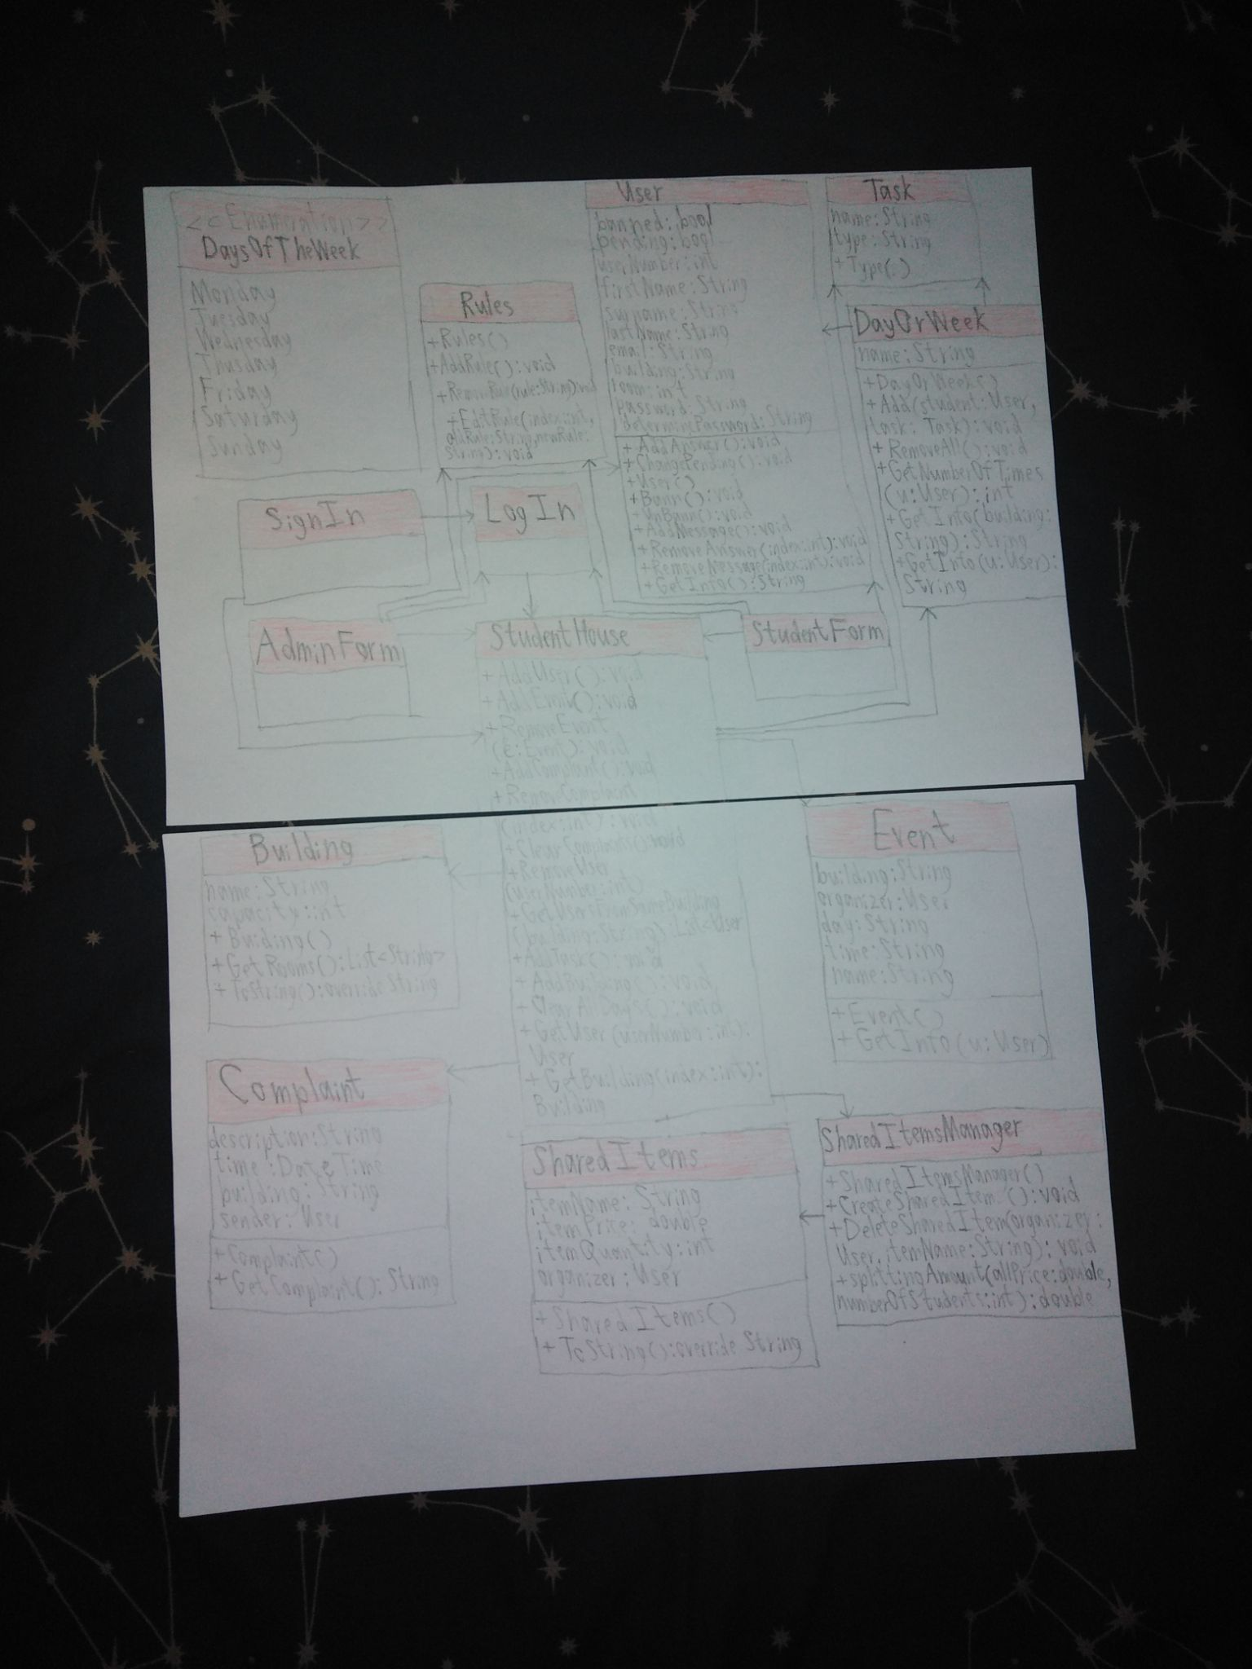

Process and Results

|  |  |  |
| --- | --- | --- |
| Week | Process | Results |
| Week 13 | Each of us presented some of their ideas about the application. Viktor did some coding and created a startup version of the login feature. Desislav presented an idea about the different features being separated by tabs and about a common chat, shared by all the tenants. Another one of his ideas was about a feature about complaints. Matija presented other features and one of his ideas was about an event feature to notify everyone else. | We came to the conclusion that the feature should be separated by tabs and should use a login feature which prevents outsiders from making an account. We also agreed that the login feature should be simplified and should only use a password and something else (like user name or number). |
| Week 14 | We separated the work among each other. Viktor made corrections to the login feature, making it more simple to use and also moved the feature to register new accounts from the startup form. Alexander is going to do the feature to register new accounts on a different form. He is also going to give an authority to the admins to approve or reject the creation of new accounts as an extra security. Desislav is going to create a feature which the students can use to send complaints to the admins and Matija is going to create the features that allow the users to create different events. | Viktor created an updated version of the login feature which sends the user to a Student Form or to an Admin Form depending on their credentials. He also created a feature which allows the admin to edit the rules and the students to view them. Alexander is almost done with the feature about registering a new account and he has only a few more things to fix. Matija and Desislav are still working on their tasks but they are almost done as well. We already have the base where we will put the other features of the application. |
| Week 15 | Alexander is going to create a feature which allows the admin to ban and approve accounts. Viktor has finished with the rules and is now going to create a feature which splits the tasks equally. Matija and Desislav are going to finish their parts and we will merge our code. | Alexander is done with the accounts in pending and the only thing left was that in the listboxes was shown only the student numbers instead of the whole information about the student and Viktor had to create temporary buttons for pending/banned accounts, to show all the information about the selected student number. Viktor also created a feature which splits the tasks equally among all the tenants. The admin can also view the tasks and how they are separated. Matija and Desislav have also finished with their parts and we will all merge our code and submit an interim version. |
| Week 16 | Now our goal is to finish the application. Alexander should create a feature which shows the students how much they have to pay for any shared item. We also need to improve some of our current features. Viktor should create a feature which allows the students to send and receive messages to and from other people from their own house. Viktor should also make sure that it is possible to separate the students in different buildings and that all the features (like the tasks, the events and the complaints) should be changed accordingly. | Viktor found a way to improve the app by deleting the buttons that display information about the accounts that are in pending mode or in banned mode. Instead he made sure that the listboxes would display the whole information and created two temporary lists to store the users. When the admin selects an item from one of the two listboxes, the exact user can be received through the help of the index, which Alexander developed later on. Viktor also made a change to the complaints feature by allowing the admin to select a complaint and write an answer to it without seeing the identity of the actual sender. Viktor also made a feature which allows both the admin and the students to send messages to other students or in the case of the admin, he can even send a message to an entire building. Viktor also fixed a minor issue on the events feature and made sure it would work and also deleted the TimePicker for the complaints and made sure that the date and time are the current ones with DateTime.Now. Also Alexander started working on a feature on which a student can add any shared items to the specific building and then separate the debt among the tenants from the same building and then register the process and save it into a collection. After that displays to the listbox all the shared items for the building from which is the logged in account. |
| Week 17 | We finished with the whole project and we had to test the app and fix some minor issues. Viktor will do a small improvement on the events feature by allowing the admin to also add events and choose a building where. We are also planning to add a variable ‘room’ to the user and to allow the admin to add new buildings to the list. Matija is going to make the design. Alexander wanted to change the names of the buildings to display an address (created from the street name and the building number) but Viktor discovered that this way the rooms (in the SignIn Form) are not always displayed correctly, so in the end we decided not to change the names. | Matija did the design of the app. Viktor found out that we had been using an older version of the app and some of the buttons gave some minor issues but he fixed all of them. Desislav created a button which allows the student to delete messages. Viktor and Alexander worked together to figure out how to add rooms to the user and make sure that the capacity of the building is not surpassed by adding a feature which shows only free rooms from the selected building which Alexander developed with cooperation with Viktor. About the buildings Alexander also added a feature which allows the admin to register new buildings related to the system. Viktor tested the entire app and fixed some minor issues and also made sure that the app wouldn’t crash. He also made a button which would delete a shared item if the one who created it wants that. |

Personal Experiences

Alexander- I had a good experience with my team. We helped each other, worked as a real team and so on. I had no issues with the other developers, except one small thing which was that Viktor changed some code of some of our features without mentioning, but that's it. Overall I had a strong team with visions and motivation to do the project which at the end of the day helped a lot for the final product. Strongly recommend them as developers.

Viktor - I learned many new things during my work on this project. I liked working with other people and utilizing new techniques. I also learned how to collaborate with other people and work out our differences to create a final version of a product. My only real issue is that some of the others didn’t come very regularly on the meetings but that’s it. The reason why I sometimes had to change some of the code of the others was because I had to improve or to complete it in order to function properly.